**Installation Guide**

<https://github.com/DH-Pub/SymphonyLtd2022>

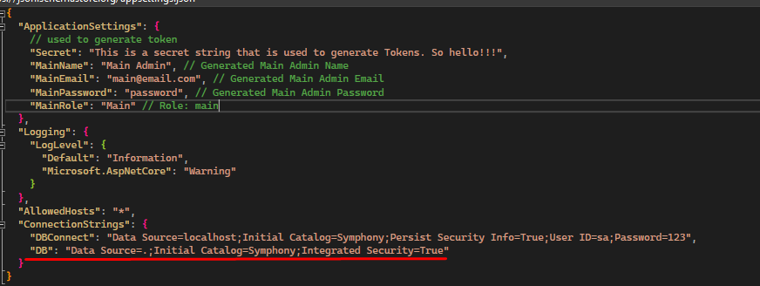

**appsettings.json**

* In Microsoft SQL Server Management Studio (SSMS)
* Create an empty database: “Symphony” 
* Run Symphony.sql (with sample data) or SymphonySchema.sql (schema only)
* Go to DataAPI -> **appsettings.json**
* Change **ConnectionStrings[“DB”]** to your own data connection
* If the database only has schema:
* Run the program
* Go to Admin, enter a random email and a random password 1 time. A main admin account will be generated with the MainEmail and MainPassword in **appsettings.json**. In this example, the login email is [main@email.com](mailto:main@email.com) and login password is “password”

